MASSACHUSETTS COULD LOWER CORRECTION COSTS IF ITS INCARCERATION RATE WERE SIMILAR TO EUROPEAN NATIONS
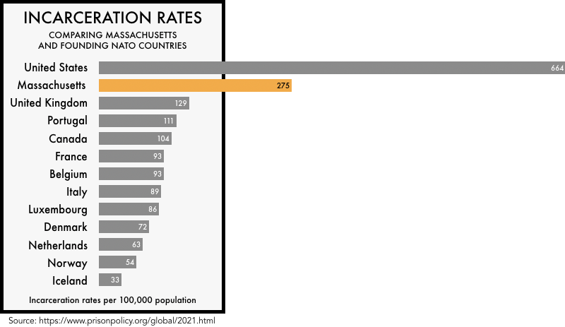
Submitted to MA Special Commission on Correctional Funding (1/11/21)
By John E. Bowman, Jr., Access to Justice Fellow

